CSE 3241 Project Checkpoint 03 – SQL and More SQL
Names: Om Kurkure, Cole Taglione, Mitchell Zahner, Sayan Bisi Date 3/15/2025
Submitted to the Carmen Dropbox
- Provide a current version of your ER Diagram and Relational Model as per Project Checkpoint 02. If you were instructed to change the model for Project Checkpoint 02, make sure you use the revised versions of your models
ER Diagram:
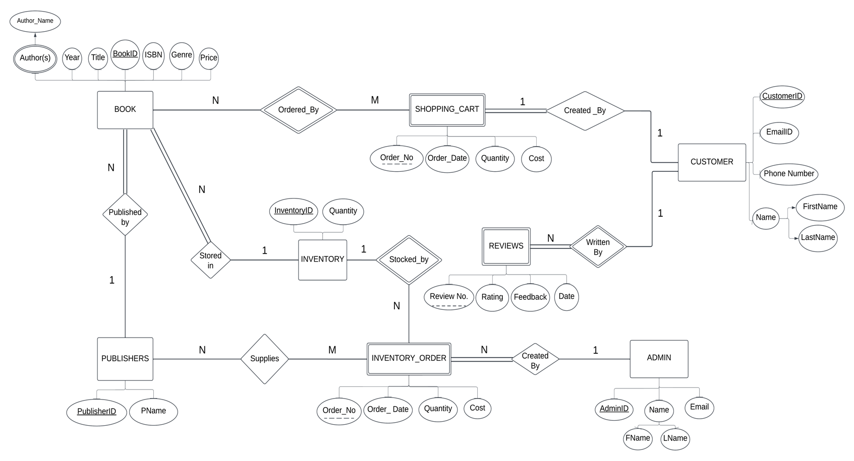
Relational Model:
ADMIN(AdminID#, FirstName, LastName, Email)
INVENTORY_ORDER(Order_No#, Order_Date, InventoryID^{(FK)}, AdminID^{(FK)}, BookID^{(FK)}, Quantity, Cost)
BOOK(BookID#, PublisherID^{(FK)}, InventoryID^{(FK)}, Title, Year, Genre, ISBN, Price)
PUBLISHERS(PublisherID#, PName)
SUPPLIES(Order_No^{(FK)}, PublisherID^{(FK)})
BOOKS_AUTHOR(BookID#^{(FK)}, Author_Name)
INVENTORY(InventoryID#, Quantity)
CUSTOMER(CustomerID#, FirstName, LastName, Email, Phone_Number)
SHOPPING_CART(Order_No#, Order_Date, CustomerID^{(FK)}, BookID^{(FK)}, Quantity, Cost)
REVIEW(Review_No#, CustomerID^{(FK)}, Rating, Feedback, Date)

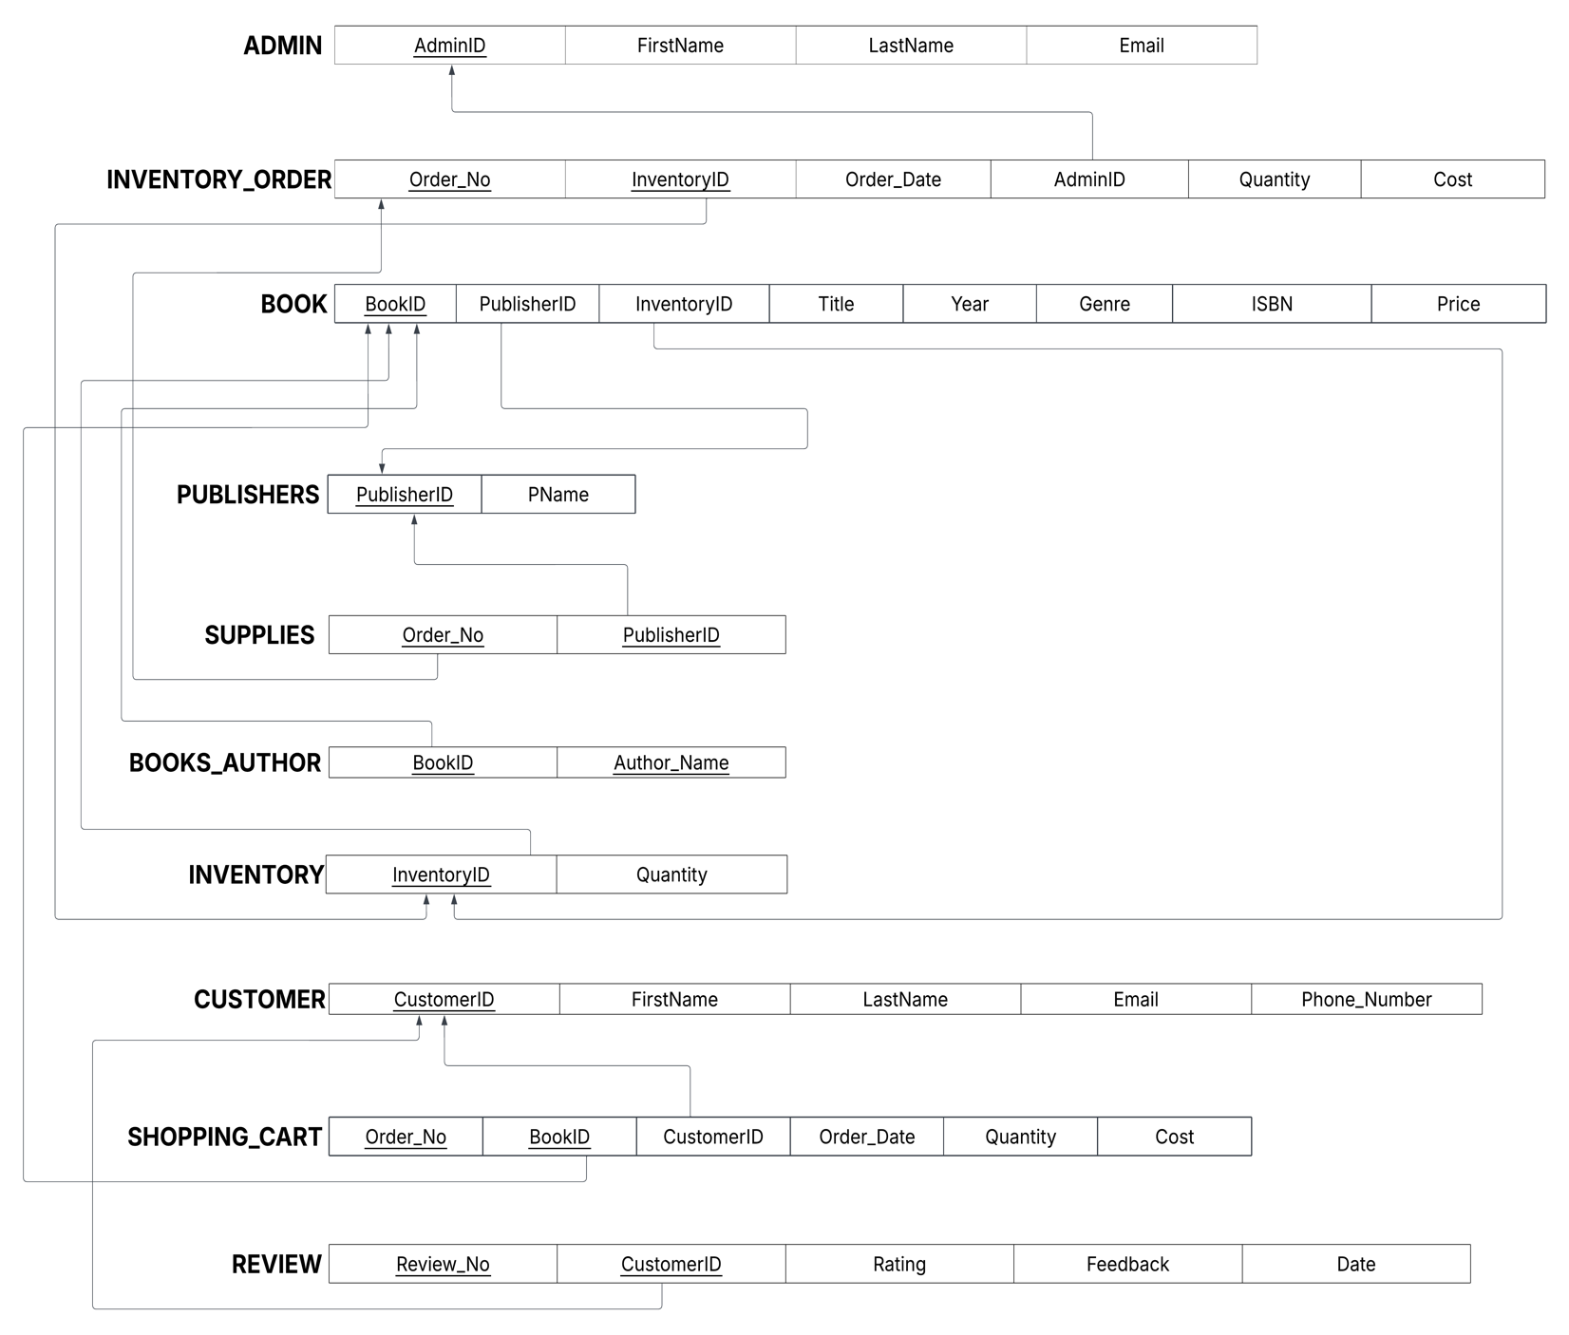

- Given your relational schema, create a text file containing the SQL code to create your database schema. Use this SQL to create a database in SQLite. Populate this database with the data provided for the project as well as 20 sample records for each table that does not contain data provided in the original project documents.

Bookstore.txt contains the create table statements

- Given your relational schema, provide the SQL to perform the following queries. If your schema cannot provide answers to these queries, revise your ER Model and your relational schema to contain the appropriate information for these queries. These queries should be provided in a plain text file named “WorksheetTwoSimpleQueries.txt”:

  - Find the titles of all books by Pratchett that cost less than $10

SELECT BookID, Book.Title
FROM Book NATURAL JOIN Books_Author
WHERE Books_Author.AuthorName LIKE '%Pratchett%' AND Book.Price < 10;

  - Give all the titles and their dates of purchase made by a single customer (you choose how to designate the customer)

SELECT Book.Title, Shopping_Cart.Order_Date
FROM Book NATURAL JOIN Shopping_Cart
WHERE Shopping_Cart.CustomerID = 5;
  - Find the titles and ISBNs for all books with less than 5 copies in stock
SELECT Book.Title, Book.ISBN
FROM Book JOIN Inventory ON Book.InventoryID = Inventory.InventoryID
WHERE Inventory.Quantity < 5;
  - Give all the customers who purchased a book by Pratchett and the titles of Pratchett books they purchased
SELECT Customer.CustomerID, Customer.FirstName, Customer.LastName, Book.Title
FROM Books_Author NATURAL JOIN Book
JOIN Shopping_Cart ON Book.BookID = Shopping_Cart.BookID
JOIN Customer ON Shopping_Cart.CustomerID = Customer.CustomerID
WHERE Books_Author.AuthorName LIKE '%Pratchett%';
  - Find the total number of books purchased by a single customer (you choose how to designate the customer)
SELECT CustomerID, Book_Count
FROM (SELECT CustomerID, COUNT(*) AS Book_Count
FROM Shopping_Cart
GROUP BY CustomerID)
WHERE CustomerID = 1;
  - Find the customer who has purchased the most books and the total number of books they have purchased
SELECT CustomerID, MAX(Book_Count) AS Max_Count
FROM (SELECT CustomerID, COUNT(*) AS Book_Count
FROM Shopping_Cart
GROUP BY CustomerID);

- For Project Checkpoint 02, you were asked to come up with three additional interesting queries that your database can provide. Give what those queries are supposed to retrieve in plain English, as relational algebra and then as SQL. Your queries should include joins and at least one should include an aggregate function, and they should be the same as the queries you outlined for Worksheet 02. If you were instructed to fix the queries in Checkpoint 02, make sure you use the fixed queries here. These queries should be provided in a plain text file named “WorksheetTwoExtraQueries.txt”.

  - Find count of ratings per Customer and average rating per Customer along with Customer name and email

SELECT Customer.FirstName, Customer.LastName, COUNT(Rating) AS Rating_Count, AVG(Rating) as Avg_Rating, Customer.Email
FROM Reviews JOIN Customer ON Reviews.CustomerID = Customer.CustomerID
GROUP BY Reviews.CustomerID;

  - Find all stock orders made for books by ‘Pratchett’ and retrieve admin details, date of order, quantity, and cost
SELECT Admin.FirstName, Admin.LastName, Book.Title, Inventory_Order.InventoryID, Inventory_Order.Order_Date, Inventory_Order.Quantity, Inventory_Order.Cost
FROM Inventory_Order JOIN Book ON Inventory_Order.InventoryID = Book.InventoryID
JOIN ADMIN ON Inventory_Order.AdminID = ADMIN.AdminID
JOIN Books_Author ON Book.BookID = Books_Author.BookID
WHERE Books_Author.AuthorName LIKE '%Pratchett%';

  - Find all publishers for books authored by ‘Pratchett’ along with book tiltles and price
SELECT Publishers.PublisherID, Publishers.Pname, Book.Title, Book.Price
FROM Publishers NATURAL JOIN Book
JOIN Books_Author ON Book.BookID = Books_Author.BookID
WHERE Books_Author.AuthorName LIKE '%Pratchett%';

- Given your relational schema, provide the SQL for the following more advanced queries. These queries may require you to use techniques such as nesting, aggregation using having clauses, and other techniques. If your database schema does not contain the information to answer to these queries, revise your ER Model and your relational schema to contain the appropriate information for these queries. Note that if your database does contain the information but in non-aggregated form, you should NOT revise your model but instead figure out how to aggregate it for the query! These queries should be provided in a plain text file named “WorksheetTwoAdvancedQueries.txt”.

  - Provide a list of customer names, along with the total dollar amount each customer has spent.
SELECT Customer.FirstName, Customer.LastName, Sum(Cost) as Amount_Spent
FROM Customer JOIN Shopping_Cart ON Customer.CustomerID = Shopping_Cart.CustomerID
GROUP BY Customer.CustomerID;

  - Provide a list of customer names and e-mail addresses for customers who have spent more than the average customer.
SELECT Shopping_Cart.CustomerID, Customer.FirstName, Customer.LastName, Customer.Email, SUM(Cost) as Total_Expenditure
FROM Shopping_Cart
JOIN Customer ON Shopping_Cart.CustomerID = Customer.CustomerID
GROUP BY Shopping_Cart.CustomerID
HAVING Total_Expenditure >
(SELECT AVG(TotalSpent) FROM
(SELECT SUM(Cost) AS TotalSpent
FROM Shopping_Cart
GROUP BY CustomerID));

  - Provide a list of the titles in the database and associated total copies sold to customers, sorted from the title that has sold the most individual copies to the title that has sold the least.
SELECT BookID, Book.Title, SUM(Quantity) as Copies_Sold
FROM Book NATURAL JOIN Shopping_Cart
GROUP BY BookID
ORDER BY Copies_Sold DESC;

  - Provide a list of the titles in the database and associated dollar totals for copies sold to customers, sorted from the title that has sold the highest dollar amount to the title that has sold the smallest.
SELECT BookID, Book.Title, SUM(Cost) as Dollar_Total
FROM Book NATURAL JOIN Shopping_Cart
GROUP BY BookID
ORDER BY Dollar_Total DESC;

  - Find the most popular author in the database (i.e. the one who has sold the most books)
SELECT Books_Author.AuthorName, SUM(Quantity) as Copies_Sold
FROM Books_Author NATURAL JOIN Shopping_Cart
GROUP BY BookID, AuthorName
ORDER BY Copies_Sold DESC;

  - Find the most profitable author in the database for this store (i.e. the one who has brought in the most money)
SELECT Books_Author.AuthorName, SUM(Cost) as Profit_Generated
FROM Books_Author NATURAL JOIN Shopping_Cart
GROUP BY BookID, AuthorName
ORDER BY Profit_Generated DESC;

  - Provide a list of customer information for customers who purchased anything written by the most profitable author in the database.
SELECT Customer.FirstName, Customer.LastName, Customer.Email
FROM Customer JOIN Shopping_Cart ON Customer.CustomerID = Shopping_Cart.CustomerID
JOIN Books_Author ON Shopping_Cart.BookID = Books_Author.BookID
WHERE Books_Author.AuthorName IN
(SELECT Books_Author.AuthorName
FROM Books_Author NATURAL JOIN Shopping_Cart
GROUP BY BookID, AuthorName
ORDER BY SUM(Cost) DESC
LIMIT 1);

  - Provide the list of authors who wrote the books purchased by the customers who have spent more than the average customer.
SELECT Books_Author.AuthorName
FROM Books_Author NATURAL JOIN Shopping_Cart
WHERE CustomerID IN
(SELECT Shopping_Cart.CustomerID
FROM Shopping_Cart
JOIN Customer ON Shopping_Cart.CustomerID = Customer.CustomerID
GROUP BY Shopping_Cart.CustomerID
HAVING SUM(Cost) >
(SELECT AVG(TotalSpent)
FROM (SELECT SUM(Cost) AS TotalSpent
FROM Shopping_Cart
GROUP BY CustomerID))
);

Once you have completed all of the questions for Part Two, create a ZIP archive containing the binary SQLite file and the three text files and submit this to the Carmen Dropbox. Make sure your queries work against your database and provide your expected output before you submit them!

